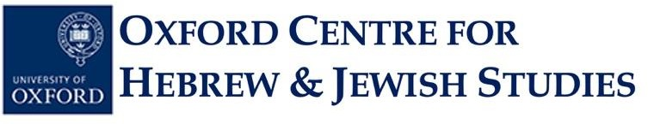
STUDENT APPLICATION FORM, 2026-27

JEWISH MUSIC CLASS

Yiddish Song Cultures, from the 1300s to the 21st Century

Michaelmas Term 2026

Tutor: Dr Diana Matut
Online course via Zoom on Mondays 18:15 to 19:15 (UK time)

Note: The number of places available for this music class is limited. Priority will be given to applicants who are current university students, but other candidates will be considered. This class is free of charge.

Surname: ……………………………………………………………………………………………......

Forename(s): . . . . . . . . . . . . . . . . . . . . . . . . . . . . . . . . . . . . . . . . . . . . . ………………………

Email Address: . . . . . . . . . . . . . . . . . . . . . . . . ……………………………………………………....

Postal Address: ……………………………………………………………………………………...

…………………………………………………………………………………………………………

Contact Phone Number: ……………………………………………………………………………

Education (current or previous school[s]/university[ies], degree level[s] and subject area[s], graduation date[s]):

……………………………………………………………………………………………………………………

Please submit your completed application form as a Word document to the OCHJS Academic Administrator, Ms Priscilla Lange, by email at academic.administrator@ochjs.ac.uk no later than Wednesday, 14 October 2026 (Week 1) at 12 noon (Oxford time).

Individuals whose applications are successful will be notified on Thursday 13 October 2026. The first day of class for this course will be Monday, 19 October 2026 (Week 2 of Michaelmas Term 2026). There will be no Jewish music classes on 12th of October and 9th of November 2026. These classes will be held on December 7th and 14th 2026 at the same time.

University of Oxford dates of term are as follows:
Michaelmas 2026: Sunday 11 October-Saturday 5 December
Hilary 2027: Sunday 17 January-Saturday 13 March
Trinity 2027: Sunday 25 April-Saturday 19 June

**************************************************************************************************************

Michaelmas Term 2026

Yiddish Song Cultures, from the 1300s to the 21st Century

Mondays, 18:15-19:15 UK Time, Online via Zoom

This year-long course presents the history of Yiddish sung epic poetry, ballads and songs from the medieval period to the 21st century. We will focus on approximately one song per week, explore its cultural context, musical performance practices, textual transmission, changes and adaptations.

Everybody is welcome to join the course, translations from Yiddish to English will be provided.

During the first term (Michaelmas 2026) we will focus on pre-modern Yiddish song cultures from the medieval period to the 18th century.

Applications will remain open until Wednesday, 14 October 2026 no later than 12 noon UK time (You can check time-zone comparisons on sites such as this one).

Individuals whose applications are successful will be notified on Thursday, 15 October 2026.

The first day of class for this course will be Monday, 19 October 2026 (Week 2 of Michaelmas Term).

If you have any queries, please contact Ms Priscilla Lange at academic.administrator@ochjs.ac.uk

