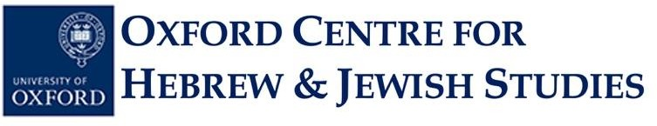
OXFORD SCHOOL OF RARE JEWISH LANGUAGES
STUDENT APPLICATION FORM, 2025-26

JEWISH MUSIC CLASS

The Sound of the kley zemer
Jewish instrumental music until 1800

Michaelmas Term 2025

Tutor: Dr Diana Matut
Online course via Zoom on Mondays 18:15 to 19:15 (UK time)

Note: The number of places available for this music class is limited. Priority will be given to applicants who are current university students, but other candidates will be considered. This class is free of charge.

Surname: ……………………………………………………………………………………………...

Forename(s): . . . . . . . . . . . . . . . . . . . . . . . . . . . . . . . . . . . . . . . . . . . . . . . . . . . ………………………

Email Address: . . . . . . . . . . . . . . . . . . . . . . . . ……………………………………………………....

Postal Address: ……………………………………………………………………………………..

…………………………………………………………………………………………………………

Contact Phone Number: . . . . . . ……………………………………………………………………………….

Education (current or previous school[s]/university[ies], degree level[s] and subject area[s], graduation date[s]):

………………………………………………………………………………………………………………………

……………………………………………………………………………………………………………………….

Please submit your completed application form as a Word document to the OCHJS Academic Administrator, Ms Priscilla Lange, by email at academic.administrator@ochjs.ac.uk no later than Wednesday 17 October 2025 at 12 noon (Oxford time).

Individuals whose applications are successful will be notified on Thursday 18 October 2025. The first day of class for this course will be Monday, 20 October 2025.

University of Oxford dates of term are as follows:
Michaelmas 2025: Sunday 12 October-Saturday 6 December
Hilary 2026: Sunday 18 January-Saturday 14 March
Trinity 2026: Sunday 26 April-Saturday 20 June

***************************************************************************************************************

Michaelmas Term 2025

The Sound of the kley zemer
Jewish instrumental music until 1800

Mondays, 18:15-19:15 UK Time, Online via Zoom

Although vocal music is intimately linked to the Jewish experience, instruments and instrumental music have been part of Jewish culture since Biblical times. This term, we will explore the history of instruments in Jewish contexts, their usage, prohibitions and surrounding social and religious discussions as well as Jewish instrumental music written until around 1800.

Applications will remain open until Wednesday, 17 October 2025 no later than 12 noon UK time (You can check time-zone comparisons on sites such as this one).

Individuals whose applications are successful will be notified on Thursday, 18 October 2025.

The first day of class for this course will be Monday, 20 October 2025 (Week 2 of Michaelmas Term).

If you have any queries, please contact Ms Priscilla Lange at academic.administrator@ochjs.ac.uk

