Oxford Centre for Hebrew and Jewish Studies
Hilary Term 2012
European Seminar on Advanced Jewish Studies
OLD YIDDISH: OLD TEXTS, NEW CONTEXTS
Convenors: Prof Simon Neuberg, Dr Zehavit Stern
Thursdays 2.00-4.00pm in the Radcliffe Science Library (RSL)

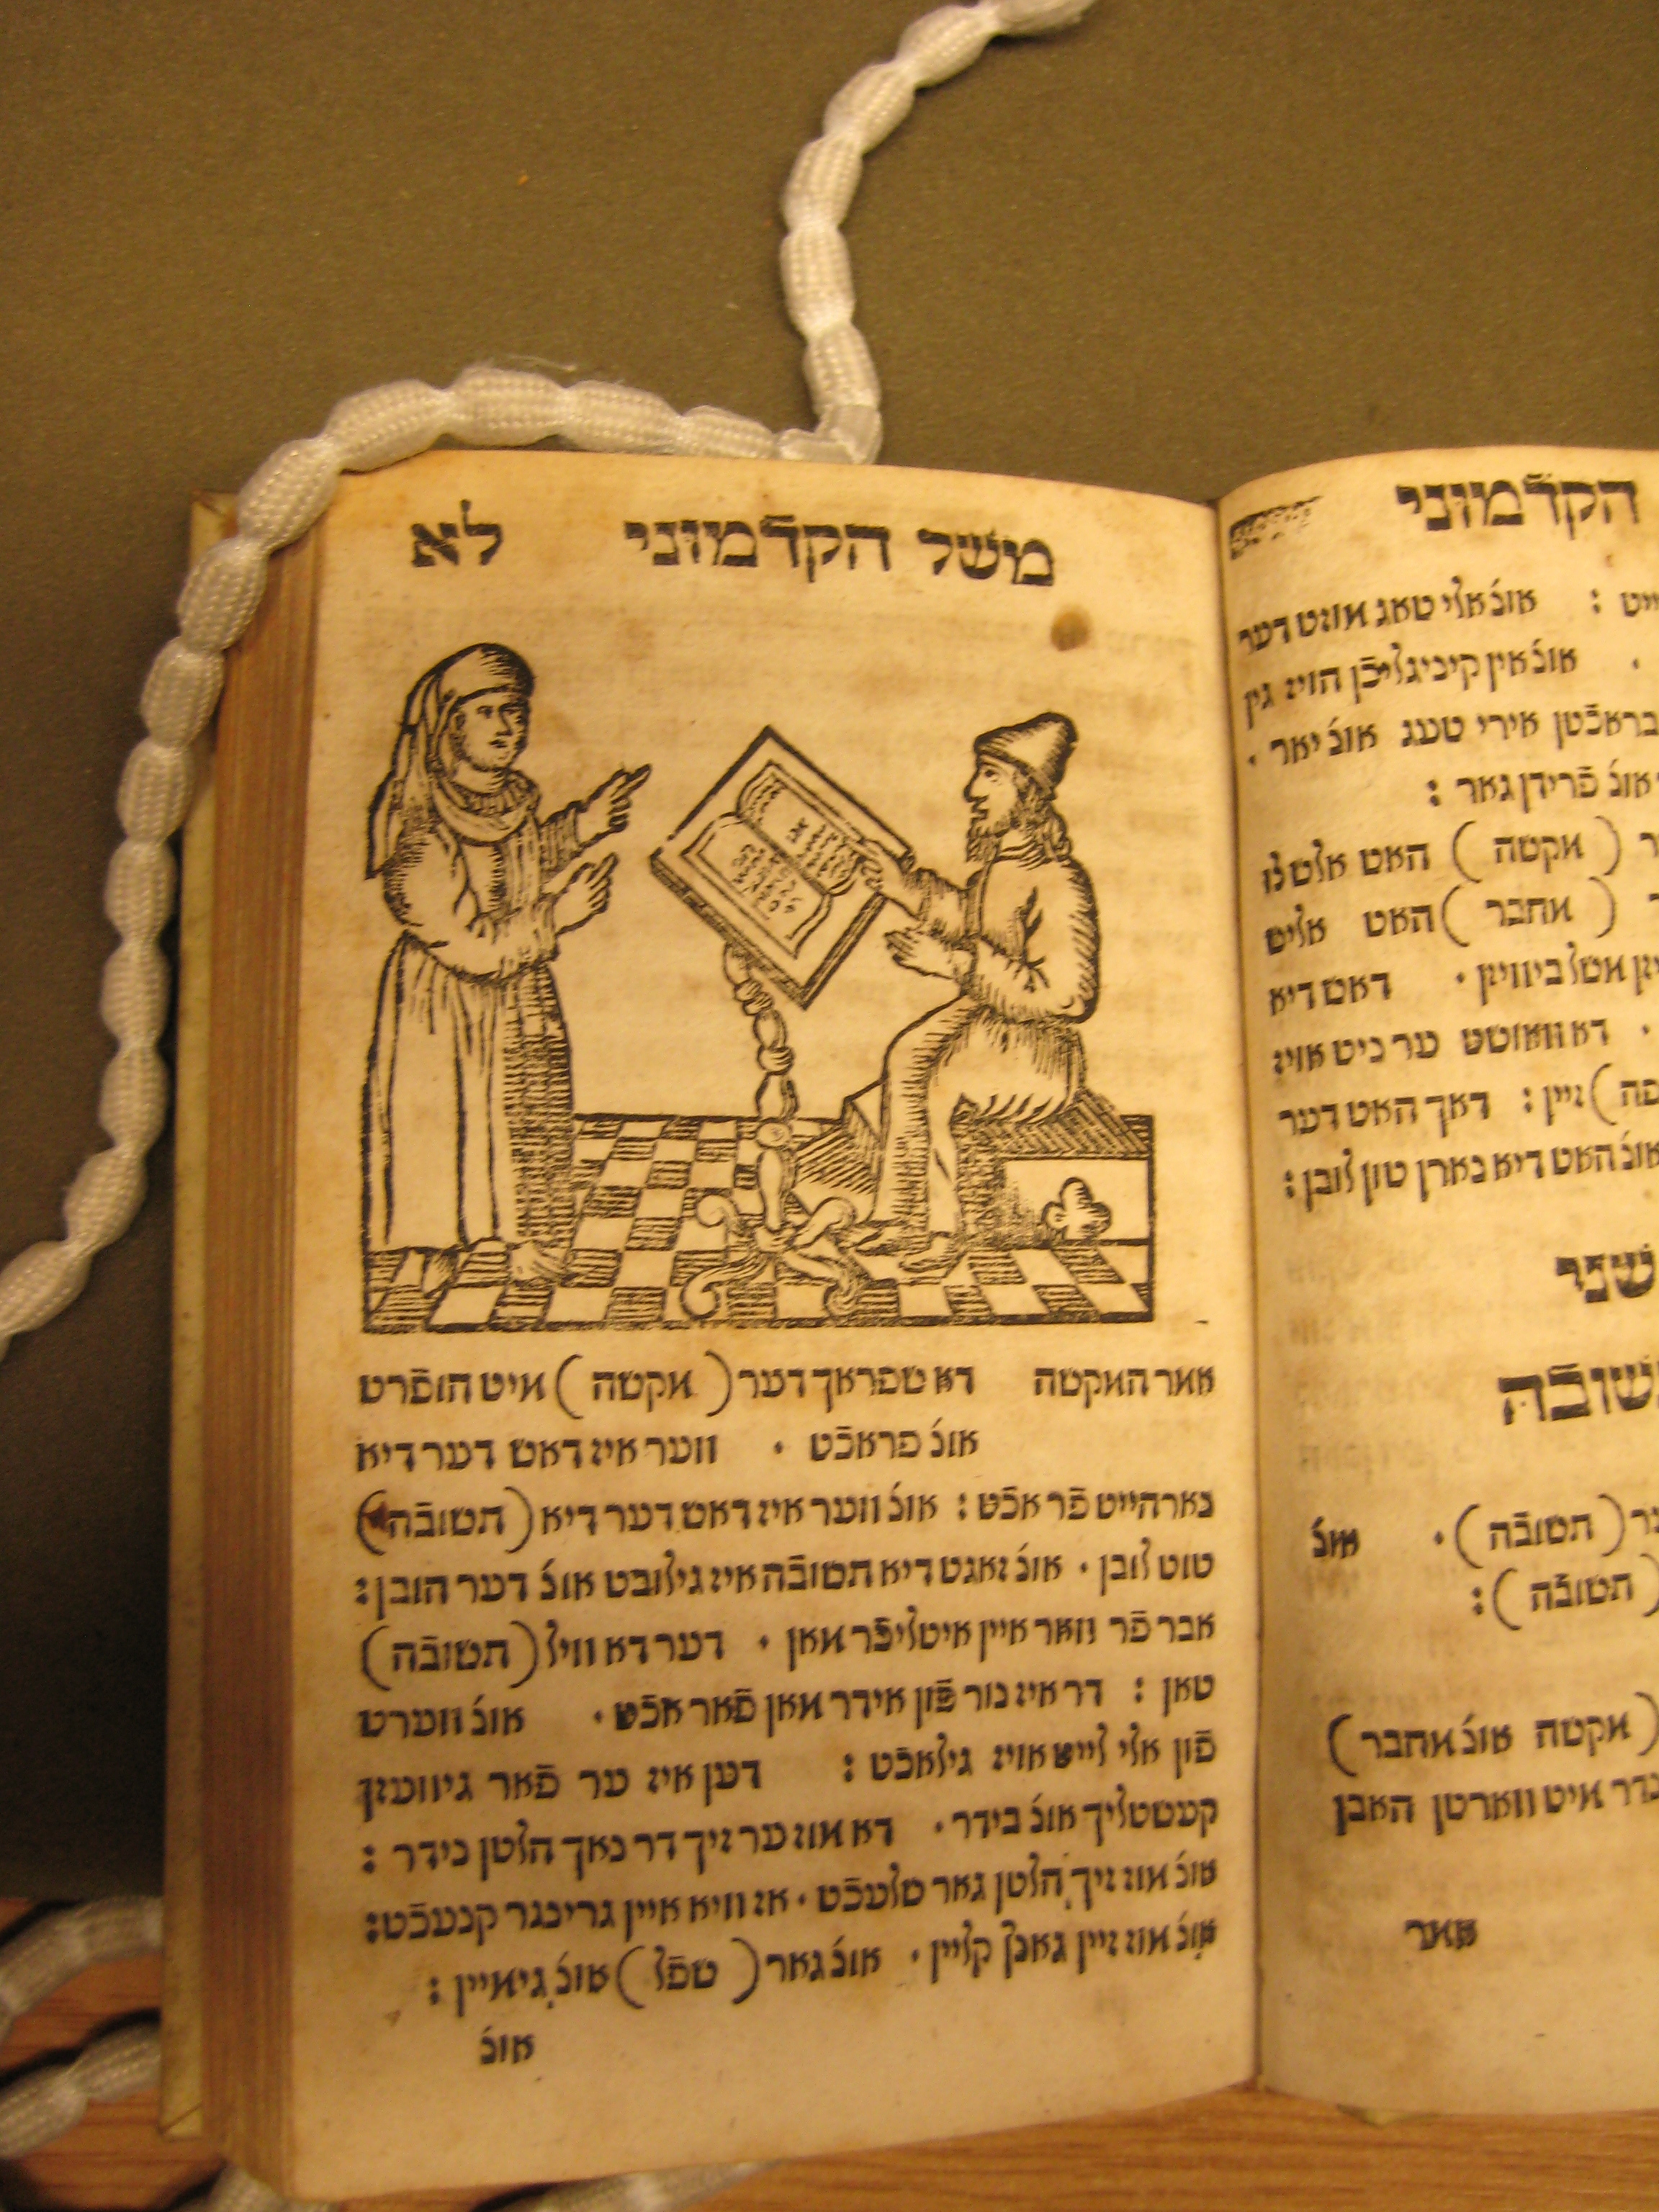

Jan 19: Wiebke Rasumny (Munich)
Formal and Thematic Units in the Maysebukh

Jan 26: Prof Marion Aptroot (Heinrich Heine University Düsseldorf)
Yiddish literary genres of the early modern period seen through the lens of an 18th century parody
Feb 2: Ingedore Rüdlin (Frankfurt)
The Book of Ruth in the Yiddish Tradition

Feb 9: Prof Shlomo Berger (Amsterdam)
“Five Beautiful New Songs”; an anthropological reading of Old Yiddish texts

Feb 16: Oren Roman (Hebrew University)
Idiomatic Expressions in a Non- spoken Language

Feb 23-24: CONFERENCE
(details to be announced)

Mar 1: Prof Lucia Raspe
(Goethe-Universität, Frankfurt/
Ruhr-Universität Bochum)
Murder in the Ghetto: Urban Space, Yiddish Narrative and the Medieval Past in Early Modern Worms

Mar 8: Dr Rebekka Voß (Goethe-Universität, Frankfurt) The Mildest and the Wildest of Men: Di royte yidlekh in Jewish and Christian Imagination

