HEBREW AND JEWISH STUDIES UNIT

Lunchtime Seminars in Jewish Studies
Hilary Term 2013

Thursdays 1pm
Oriental Institute, Room 314

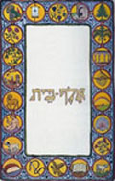

Week 3: 31 January

Alex Marshall
(Brasenose College)
Great Things Float in the Air: Duelling, Dirigibles and Zionism
without Zion

Week 6: 21 February

Jennifer Juillard-Maniece
(Brasenose College)
Two Early Modern Yiddish adaptations of medieval German literature

All welcome

(Please bring your own sandwiches; cake and drinks will be provided)

