Hebrew and Jewish Studies Unit  of the University of Oxford  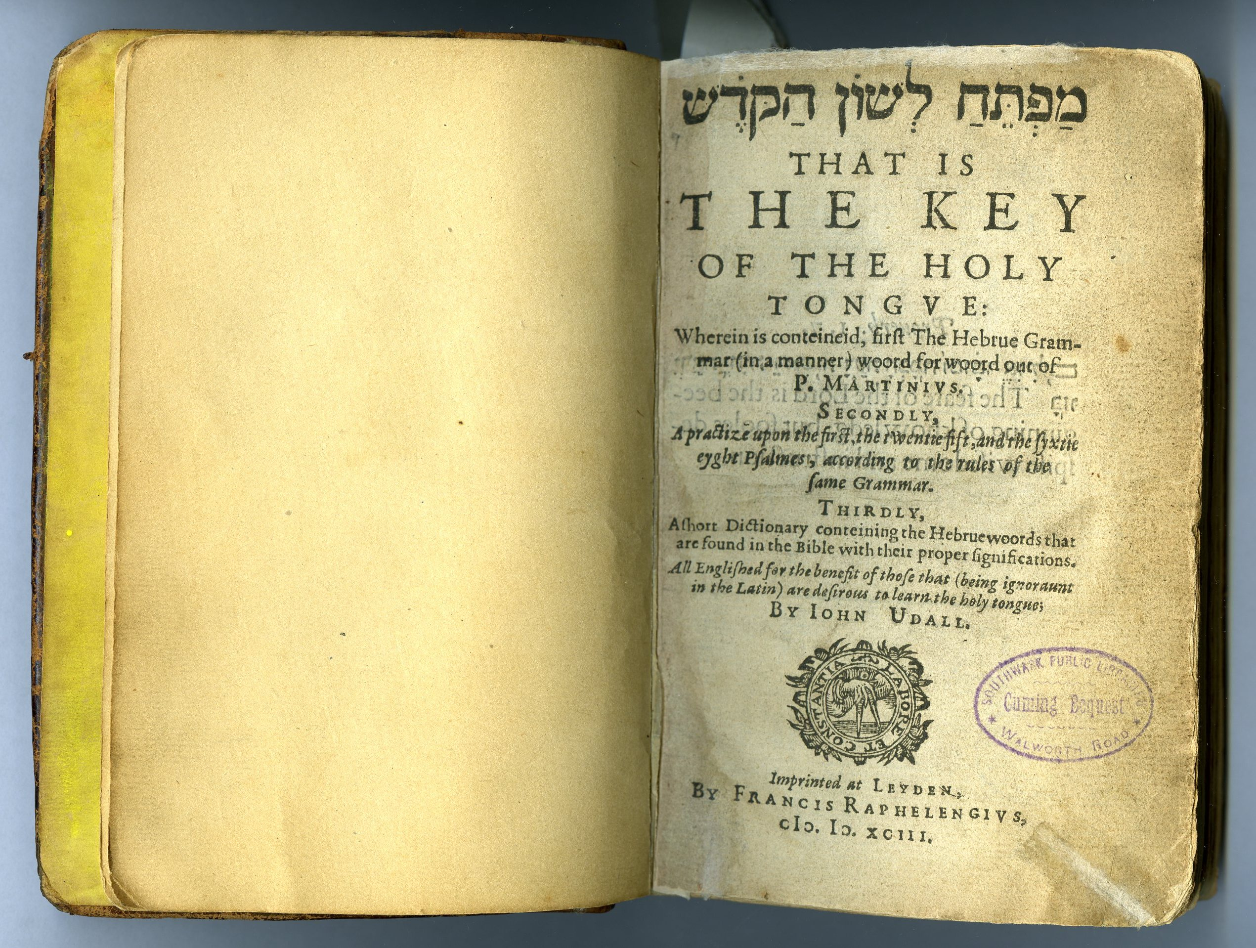  THE KING JAMES BIBLE:  THE SCHOLARLY CONTEXT  Conference  at  Exeter College    13 July 2011  Convenor: Joanna Weinberg  To register please e-mail: enquiries@ochjs.ac.uk |  | Wednesday 13 July  9.30am WELCOME  Chair: Joanna Weinberg (Oxford)  9.30–10.00am  Scott Mandelbrote (Cambridge):  Introduction: The King James Bible in the History of Scholarship  10.00–10.30am  James Carley (York University, Toronto):  Lambeth Palace in 1611: Its Contribution  to Christian Hebraism  10.30-11.10am  Alison Knight (Cambridge)  ‘This Text is a Monument':  Scriptural Citation and Sources in the  Sermons of Lancelot Andrewes  COFFEE  Chair: Piet van Boxel (Oxford)  11.30am-12.10pm  Thomas Roebuck (Oxford); Karen Collis (Oxford):  Miles Smith and the Languages of Scripture  12.10 -12.50pm  Nicholas Hardy (Oxford)  John Bois’ annotated Septuagint |  | LUNCH  followed by a visit to the  King James Bible exhibition  Chair: Ian Maclean (Oxford)  2.10-2.50pm  Anthony Grafton (Princeton):  Preparing the Way: Lively, Edward (c.1545-1605)  2.50-3.30pm  William Poole (Oxford):  Early Oxford Hebraism (1586-1617):  the view from New College  TEA  Chair: Elliott Horowitz (Bar Ilan)  3.50-4.30pm  Philip Alexander (Manchester):  The early 17th century glosses in Bomberg’s Rabbinic Bible (1525) in Chetham’s Library, Manchester  4.30-5.10pm  Theodor Dunkelgrün (Chicago):  Conduits of continental scholarship: Hadrianus Saravia’s contributions to the making of the  King James Bible  5.10-5.50pm  Joanna Weinberg (Oxford):  Richard Kilby[e, ie]’s Commentary on Exodus  “iuxta Hebraeos”

