Oxford Centre for Hebrew and Jewish Studies
Michaelmas Term 2011

European Seminar on Advanced Jewish Studies
OLD YIDDISH: OLD TEXTS, NEW CONTEXTS
Convenors: Prof Simon Neuberg, Dr Zehavit Stern
Thursdays (except week 2*) 2.00-4.30pm in the Radcliffe Science Library (RSL)

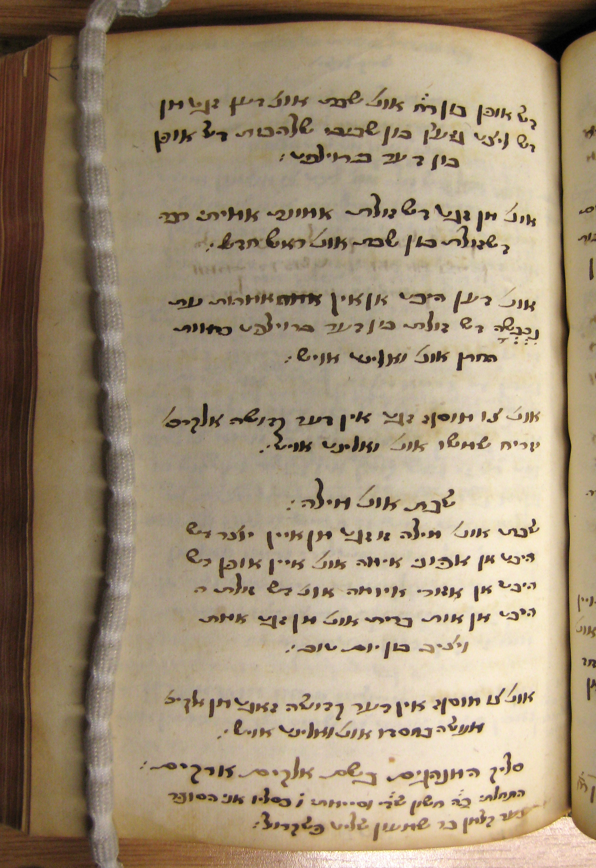

Oct 19: Prof Simon Neuberg (Trier)
(Wed) * Components of Western Yiddish Literature. The shorter genres (Part 1)

Oct 27: Dr Claudia Rosenzweig (Bar Ilan)
Rhymes to Sing and Rhymes to Hang up. Preparing a new edition of two lampoons by Elye Bokher
Nov 3: Prof Chava Turniansky
(Hebrew University)
Between Yiddish and Hebrew: Describing Daily Life and Current Events in the Early Modern Period
Nov 10: No Seminar

Nov 17: Prof Erika Timm (Trier)
The text on the Cologne slate tablet 596-10
(This paper will be in German)

Nov 24: Prof Simon Neuberg (Trier)
Components of Western Yiddish Literature. The shorter genres (Part 2)

Dec 1: Dr Diana Matut
(Halle-Wittenberg) “Ashkenaz un' Polak.”
Yiddish sources on a complex relationship in Early Modern Times

